PACKAGE MANAGERS:

* yum: Linux apt: Ubuntu apt-get: Macos pip: Python
* yum install (package name): Install a package
* yum remove (package name): Remove a package
* yum autoremove (package name): Remove a package and unused dependencies
* yum update (package name): Update a package
* yum update: Update all installed packages
* yum info (package name): Get iformation about a package
* yum list: List all available packages
* yum list (package name): List available matching packages
* yum list installed: List installed packages
* yum –showduplicates list (package name): List all available versions
* sudo apt update && sudo apt upgrade -y: Update computer at one line

Managing Files, Getting Helps:

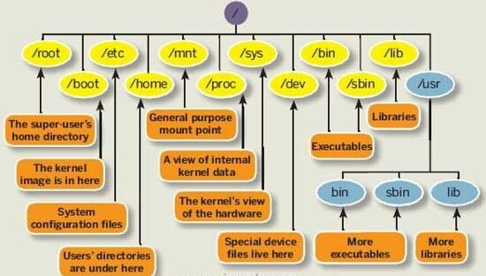

* **hostname -I:** Return IP address
* **sudo !!:** Last command will execute by sudo
* **Tab:** Automatic completion of command, file name
* **Sequential commands (separate with”;”):** command1; command2; command3
* **ping** [**www.clarusway.com**](http://www.clarusway.com) :  Troubleshooting, testing, and diagnosing network connectivity issues.
* **ssh username@host_ip**: To use computer of others

***************************************************************************

* **man:** Displays the manual page from system's documentation

Previous and Next page press **‘p’ and ‘n’** and press **‘q’** to exit

* **--help**: Which gives a short explanation about how to use the command and a list of available options.
* **info ls:**
* **whatis:** Displays brief information about a command
* **apropos:** Search the manual page names and descriptions (search keyword in man page)

Ex: apropos ls🡪give information all command include ls

* **concatenate**: One of the basic uses of cat is to concatenate files into a bigger (or complete) file.

**Find:**

* **find:** is an command for searching file(s) and folder(s) using filters such as size , access time , modification time.
* **find .** : current directory
* find /home -name fil\*: find all the files that start with “fil” in the /home directory (-i name: case insensitive for files)

**Quoting:**

Quoting is used to disable special treatment of certain characters.

The double quote protects everything enclosed except $,’,”,\

The single quote protects everthing

* **echo “$SHELL”:** /bin/bash
* **echo ‘$SHELL’:** $SHELL

**Grep:**

* grep 'word' filename: search any line that contains the word in filename on Linux.

**grep -i** Returns the results for case insensitive strings

**grep -n** Returns the matching strings along with their line number

**grep -v** Returns the result of lines not matching the search string

**grep -c** Returns the number of lines in which the results matched the search string